**Building the future of the transportation industry- Will Make Commerce Happen**

**Architecture:**

* Node.js
* Express.Js
* Mongo Db
* Angular.js
* HTML, Gmaps-API, Material Design.

By taking reference from the LEGACY (Travel Salesman Problem + OUR RESEARCH based SOLUTION) will BIRING THE OPTIMIZED SOLUTION.

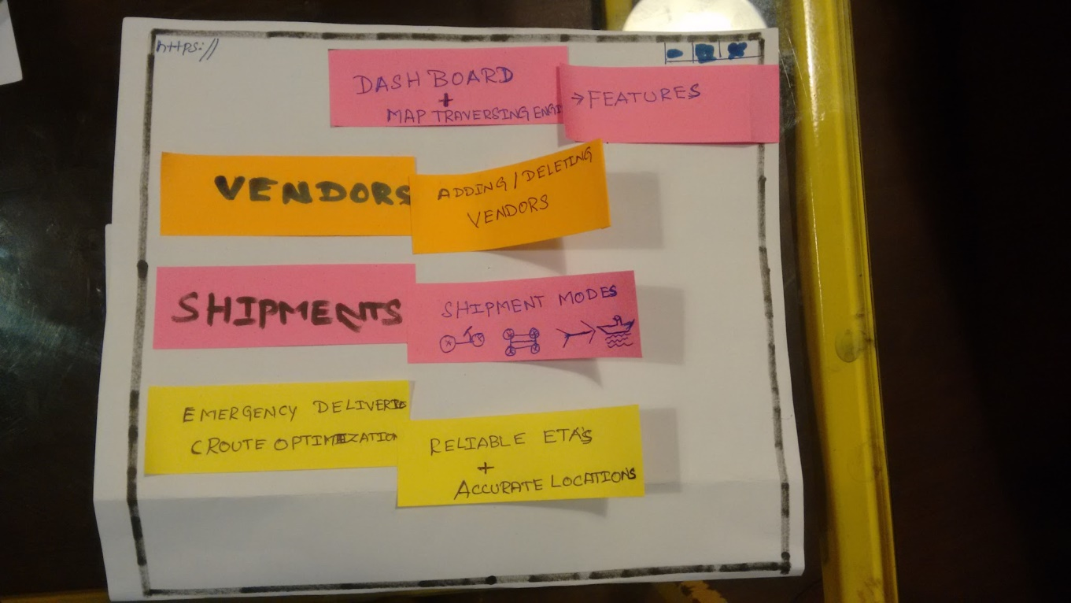

**Check lists**

1. achieving the cost effectivness
2. accomplish the reliable transport (inter/INTRA) with ETA, ROUTE optimization.
3. Partners request will be configurable.

!!!IN PROGRESS FOR BETTER TOMORRow!!!